Wandering in the Woods – Design Document

Purpose: The following document contains design documentation developed in order to use as a skeleton and guide during programming and design implementation of the user interface and core functionality of the project.

Game Design Wireframe:

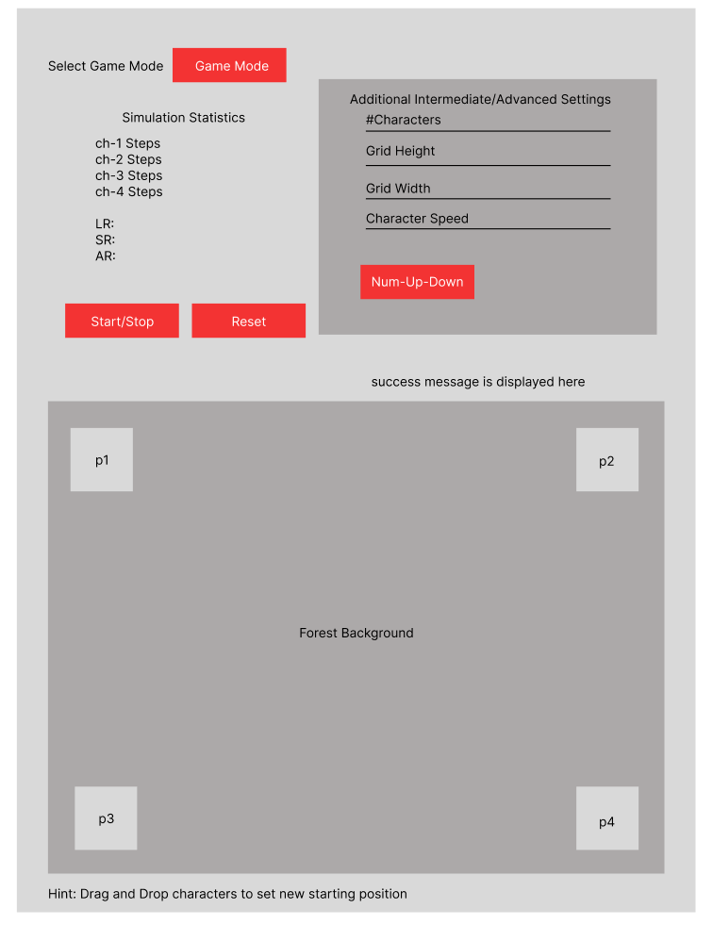

Game State Diagram:

The following stat diagram describes the basic states which the simulation will follow when a simulation has been started by the user.

-When a user initiates a simulations, the game system actions check for the gameMode selection from the drop-down values.

-Based on those values, the system starts the GameTime event which handles the character movement events and processes the simulation parameters that have been added by the user.

-Once game parameters are set, the game system dynamically calculates random paths for each characters.

-The game system then checks if characters have been found, if true it binds characters, if false it continues to calculate random paths.

-If characters are found, the system checks if all characters are found, if false then the simulation continues, if true then the simulation ends.

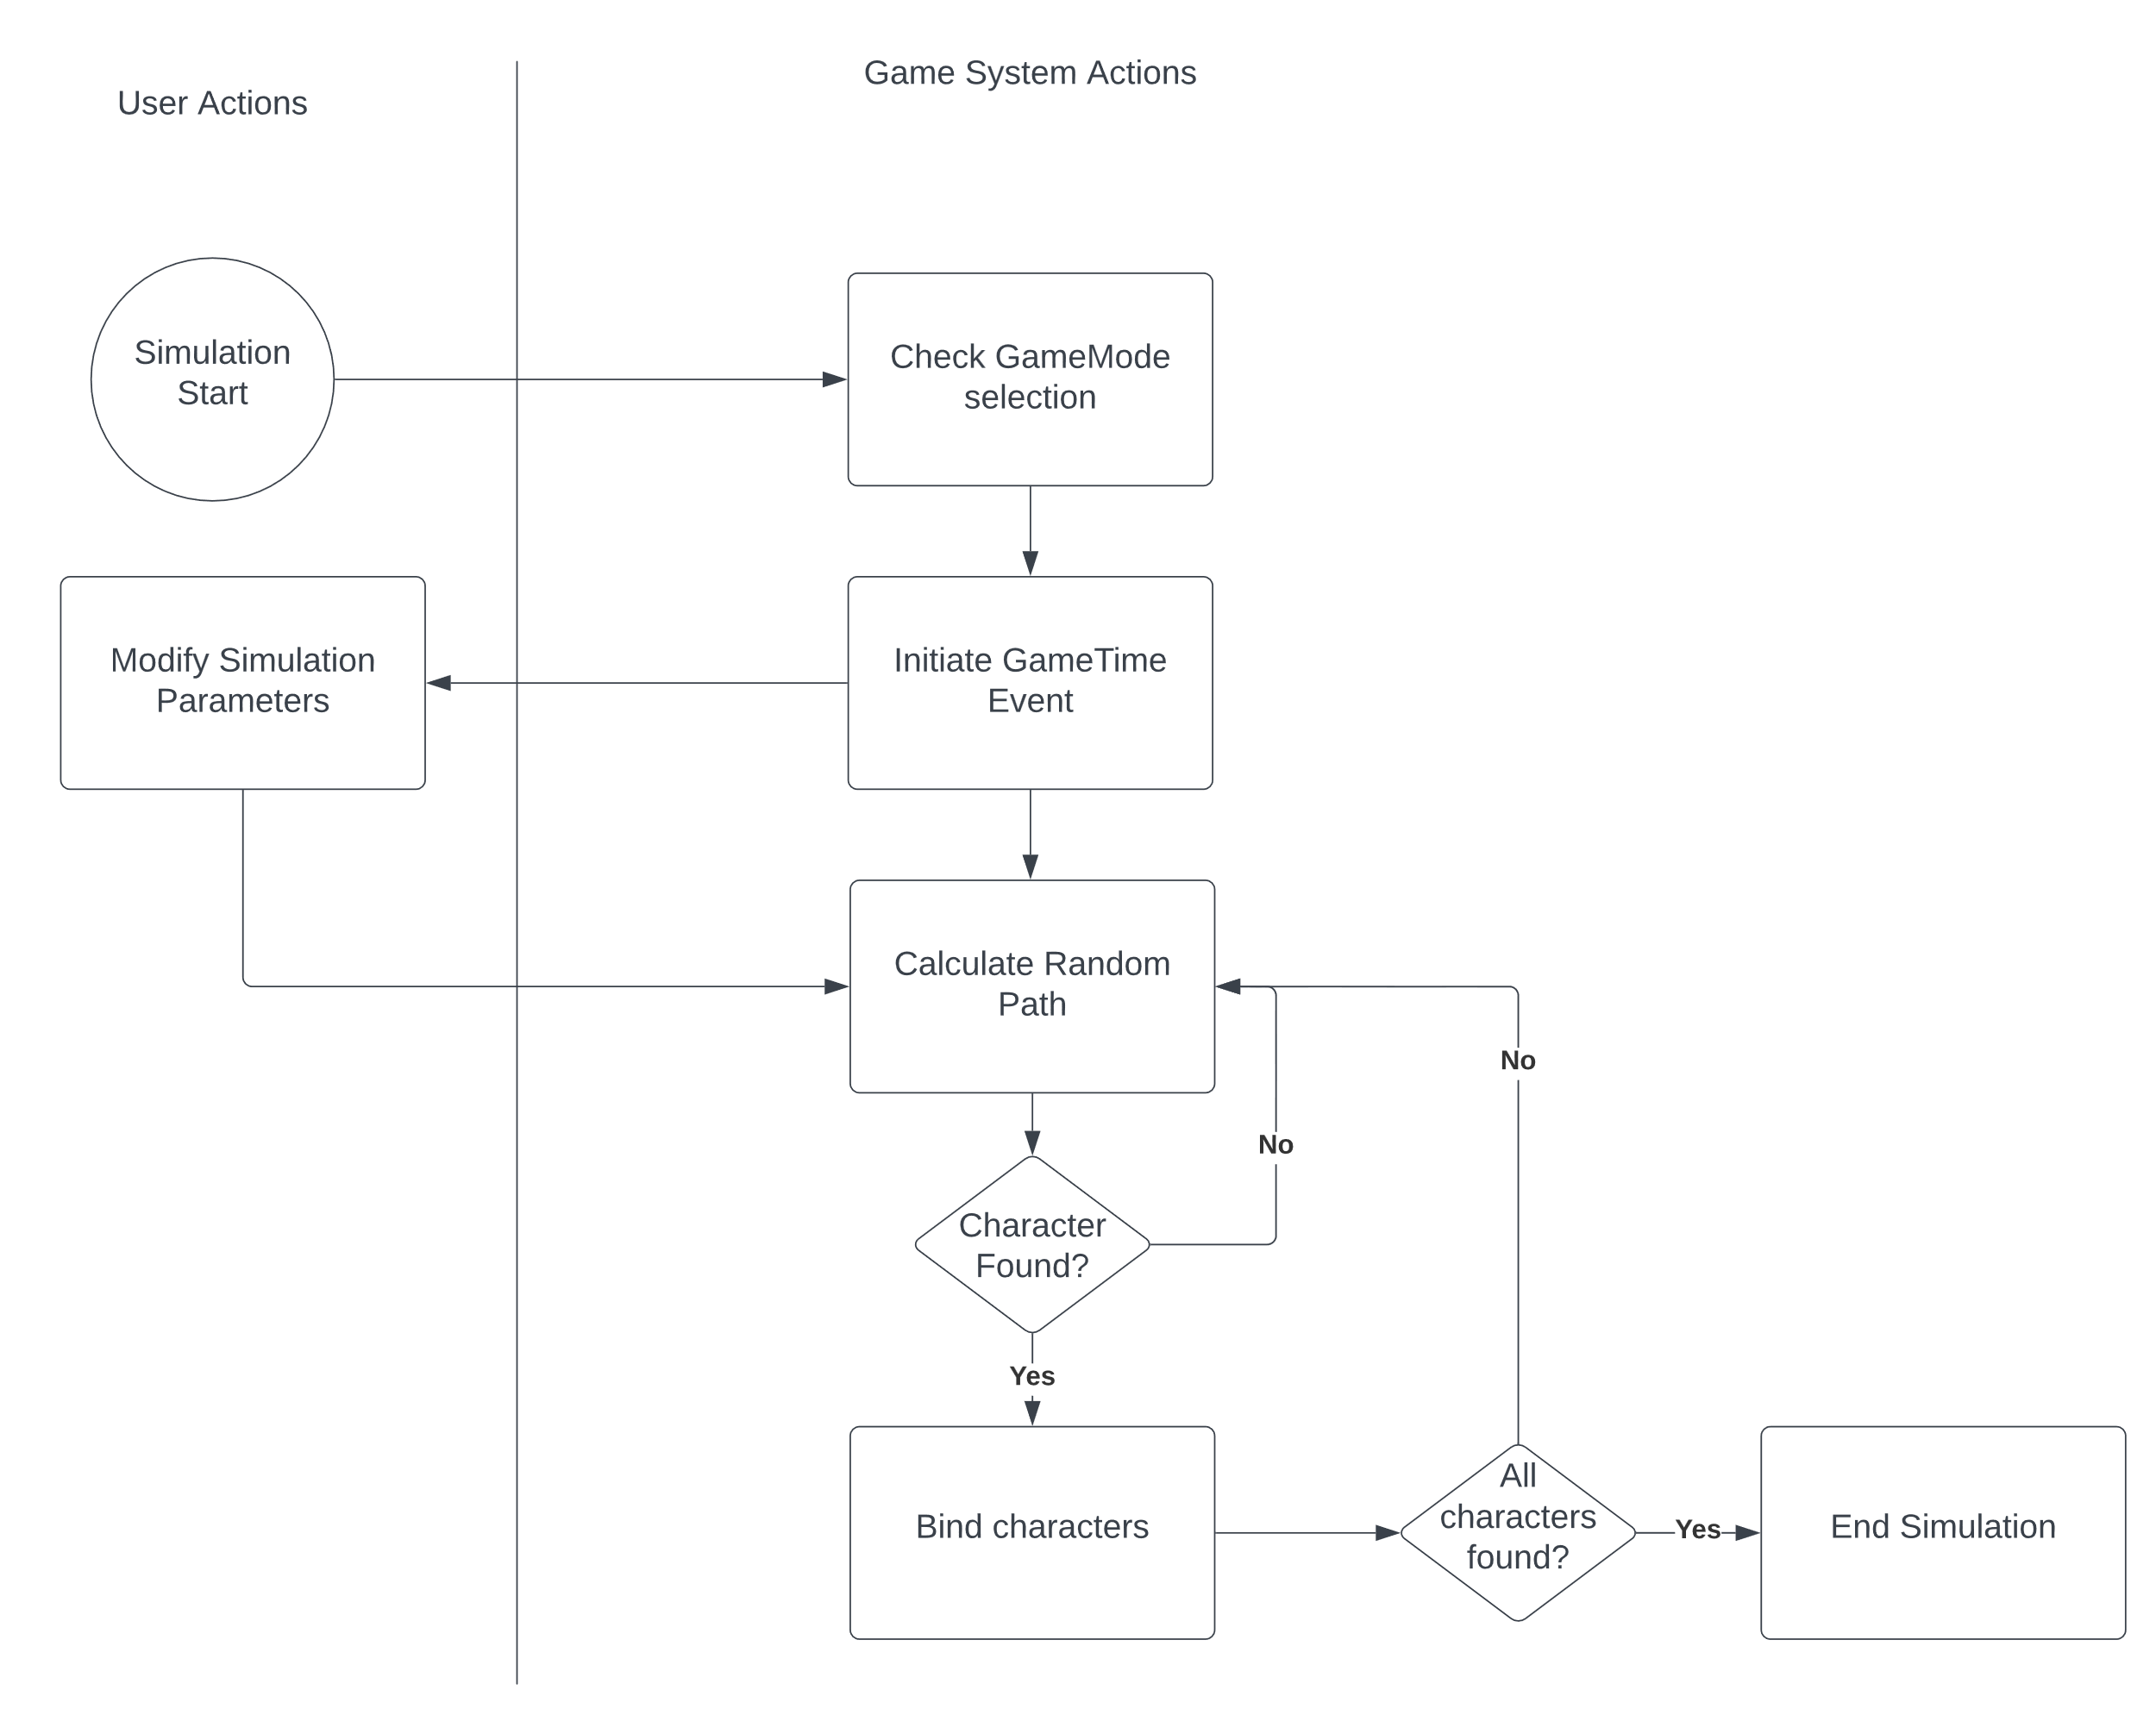

Game Simulation Use Cases

## Use Case 1: Game Mode K-2

**Primary Actor:** Students Grade K-2

**Preconditions:** A student must select the K-2 option from the simulation drop down.

**Description:** As a K-2 student, I want to be able to run a simulation of two characters, I want to be able to see characters move in a grid, I should be able to see the amount of character steps that both characters have taken. When both characters find each other, I want to be able to audibly be notified that both have been found and see an animation being played. I want to see final statistics at the end of the simulation.

**Acceptance Criteria:** I can set the game to K-2 mode and play with the given game tools

## Use Case 2: Game Mode 3-5

**Primary Actor:** Students Grade 3-5

**Preconditions:** A student must select the 3-5 (intermediate) option from the simulation drop down.

**Description:** As a grade 3-5 student, I want to be able to have all the functionality that K-2 students have, but also have more in-depth statistics such as average run, shortest run, and longest run. I want to be able to add more characters to the screen, modify the grid size, and drag and drop characters in any position in the grid.

**Acceptance Criteria:** I can set the game to 3-5 mode and have access to more custom simulation parameters.

## Use Case 3: Game Mode K-2

**Primary Actor:** Students 6-8

**Preconditions:** A student must select the 6-8 (Advanced) option from the simulation drop down.

**Description:** As a grade 6-8 student, I want to be able to have all the functionality that K-2 and 3-5 students have, but also have access to more advanced tools that allow me to change the game path behavior that is being used when randomly generating paths for the characters, I want to be able to modify the speed of the characters, and I should be able to modify the random path seed.

**Acceptance Criteria:** I can set the game to 6-8 mode and have access to the advanced character path systems.

Game Code Class Diagram

The following class diagram represents the code path and structure of the game/simulation.

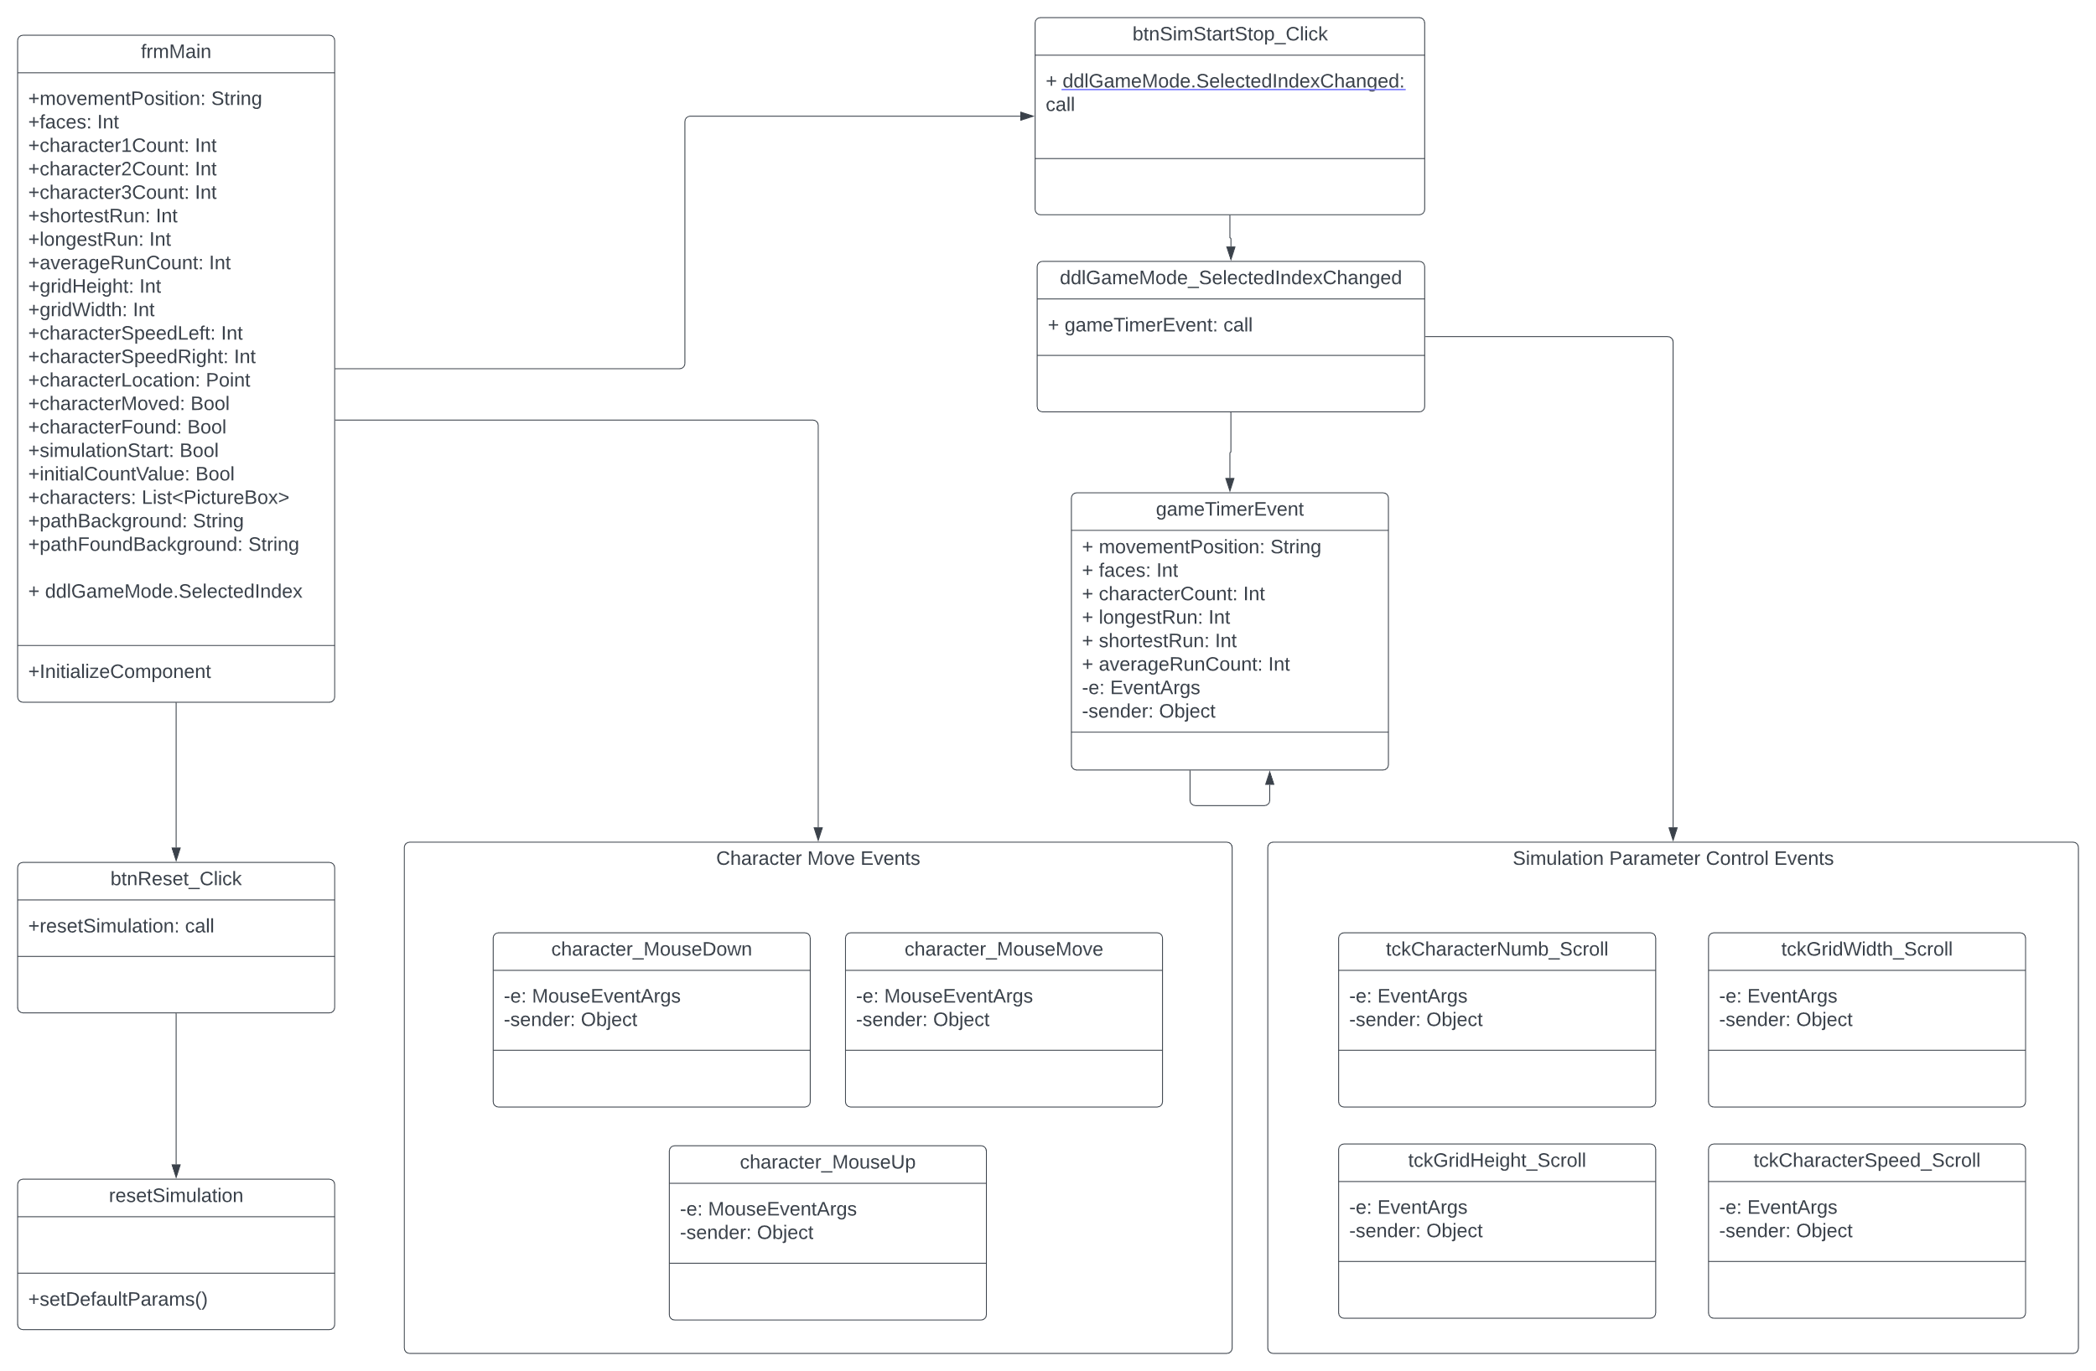

Usability Testing: